MẠNG MÁY TÍNH Final 2023-2024
Quarter 4
Section 1 (40 marks)
Question 1: What is the function of Network layer in OSI model?
A. Converting data between different formats and ensuring end-to-end data integrity
B. Providing reliable link-level data transfer between two nodes in a network
C. Establishing and maintaining a session between two applications
D. Routing packets from the source to the destination
Question 2: What is the command generated the output shown in the figure below?
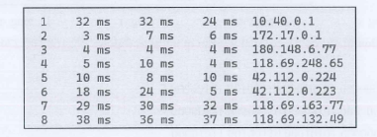
A. ping
B. tracert
C. netstat
D. nslookup
Question 3: What is the mistake of the following commands?
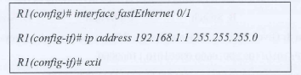
A. Assign wrong IP address
B. The interface has not been turned on
C. Assign IP address to the wrong interface
D. All of the above
Question 4: What is NOT the reason for the issue below?
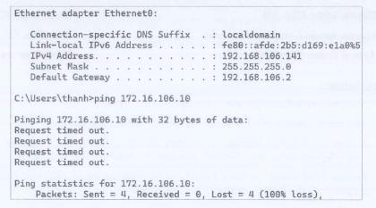
A. 2 PCs are not in the same subnet
B. The firewalls are turned off on 2 PCs
C. The cables are broken
D. 2 PCs installed different Operating System
Question 5: What is the command generated the output shown in the figure below?
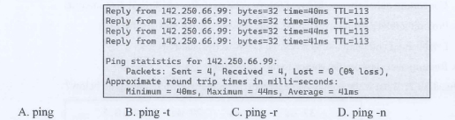
Question 6: Given the decimal version of an IP as follow: 192.168.100.224. What is the binary version of it?
А. 11000000.10101000.01100100.11100000
В. 11000000.10100100.01100100.11100000
С. 11000000.10101000.01100100.11010000
D. 11000000.10100000.01100100.11100000
Question 7: Which of the following devices is not a networking device?
A. Hub
B. Switch
C.Firewall|
D. None of the above
Question 8: Given the information as below. What is the network address of this IP?
IP: 10101100.00010000.00001010.11000000
Subnet Mask: 11111111.11111111.11111111.00000000
A. 172.16.0.0
10101100.00010000.00001010.00000000
C. 172.16.1.01
B. 172.16.2.0
D. 172.16.10.0
Question 9: Given the model as below. After configuring IP address and routing, PC1 still cannot ping to PC3. What is the reason for this error?
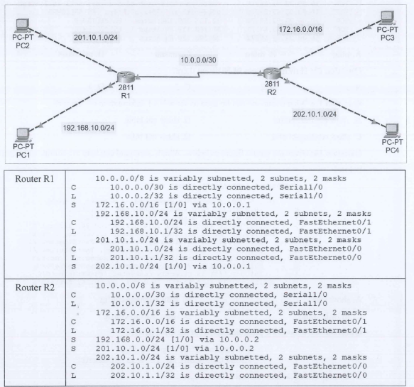
A. Wrong routing configuration on Router R2
B. Wrong routing configuration on Router R1
C. Wrong routing protocols configured on 2 routers
D. Wrong cable connecteed to 2 routers
Question 10: Assume that we have the network 192.168.100.0/24 and we want to divide it into subnets with 50 PCs each subnet. What is the last IP address of the 3rd subnet?
A. 192.168.100.191
B. 192.168.100.190
C. 192.168.100.254
D. 192.168.100.255
Question 11: What is the command generated the output shown in the figure below?
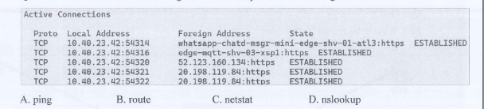

Question 12: How many types of NAT are there?
A. 1 | B. 2 | C. 3 | D. 4
Question 13: What command can be used to show NAT information on Router?
A. show nat translation
B. show nat table
C. show running-config
D. show nat into
Question 14: Given the output figure as below. Which command can help the administrator get the output below?
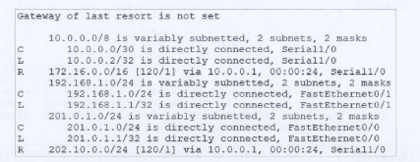
A. show vlan
B. show running-config
C. show ip route
D. show startup-config
Question 15: What is the possible reason for the error below?
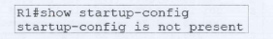
A. Start-up configuration file had not been saved
B. Wrong command
C. Wrong configuration
D. None of the above
Question 16: What is the possible reason for the result below?
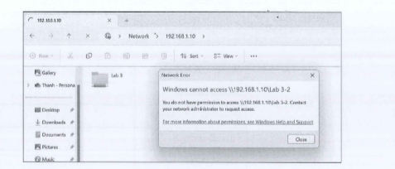
A. Wrong user name or password
B. Wrong IP address
C. No access permission for this user
D. The shared folder's name has been changed
Question 17: What cable can be used to configure routers?
A. Serial cable
B. Straight-through cable
C. Cross-over cable
D. Console cable

Question 18: Which of the following best describes a Trojan horse?
A. A self-replicating program that spreads across networks
B. A program that infects the master boot record of a system
C. A malicious program disguised as legitimate software, it will install a backdoor and steal user's information
D. All of the above
Question 19: Which command would you configure on the private network interface for Static NAT?
A. Router(config-if)#ip nat outside
B. Router(config)#ip nat inside
C. Router(config-if)#ip nat private
D. Router(config-if)#ip nat inside
Question 20: Which type of NAT is used for one-to-one mapping between local and global addresses?
A. Dynamic NAT
B. Static NAT
C. NAT Overloading
D. Symmetric NAT
Section 2 (60 marks)
Question 1: When studying at home, your computer lose connect to Internet. Base on OST model and the knowledge you have learnt, explain the error and find the way to fix it. (10 marks)
Question 2: Divide network 200.200.100.0/24 into 4 subnets using VLSM technique:
LAN1: 30 PCs
LAN2: 100 PCs
LAN3: 50 PCs
LAN4: 10 PCs
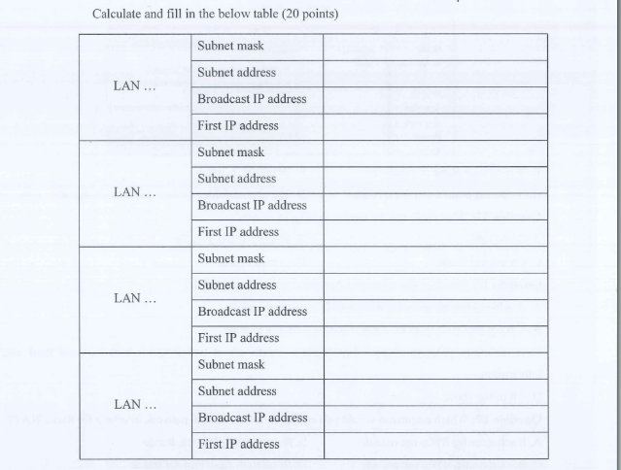
Question 3: You work as a Network Administrator for AAA Corporation. This corporation has 1/ headquarter in HCM City and 1 branch office in Ha Noi. They want to set up a network to connect those two offices together. Based on the knowledge you have learned in this class, complete the following requests:
1. Design the network model (10 pts)
2. Analyze and configure necessary services. Write down the service names and the configuration commands of each service (20pts)

